TYPES OF INHERITANCE:

1)Single Inheritance

Parent Class

Child_class

2).Multi_Level_Inheritance

Grand_Parent

**Parent**

Child

3)Hierarchical Inheritance:

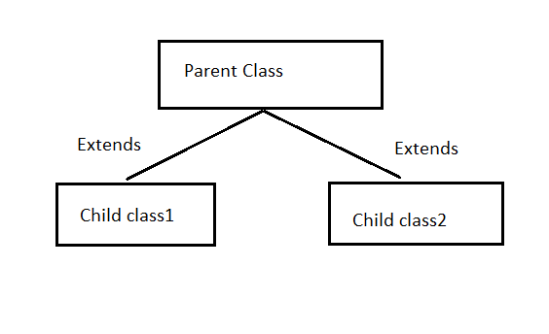

4.Hybrid

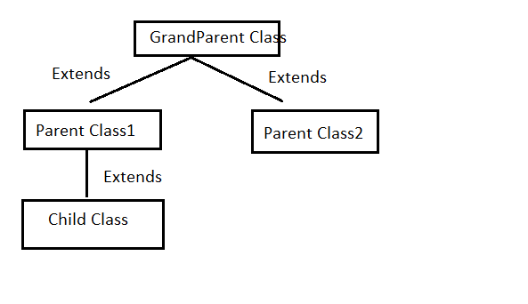

5.